Application I flustix LESS PLASTICS
Applicant /
Company
Contact Person
Telephone
Street
PO BOX
Personal E-Mail
Country
Postal Code / City
VAT ID
Do you or your Supplier
Yes
No
already hold a flustix Certification?
If Yes: Please note your license number
General Information on Certificate Issuance
Certificate & Seal lang:uages: Either English or German is mandatory! Every additional language is optional.
✔
English
French
Other:
German
Spanish
Certiﬁcate printing and issuance:
as digital version
as paper version
Issuance of a flustix Attestation
regarding the polymer content as detected in the laboratory, for the purpose of substantiating claim:
YES NO
If YES, choose language of flustix Attestation (You may select one or both):
English German
■
Page: 1 / 4 As of: 21/05/2025
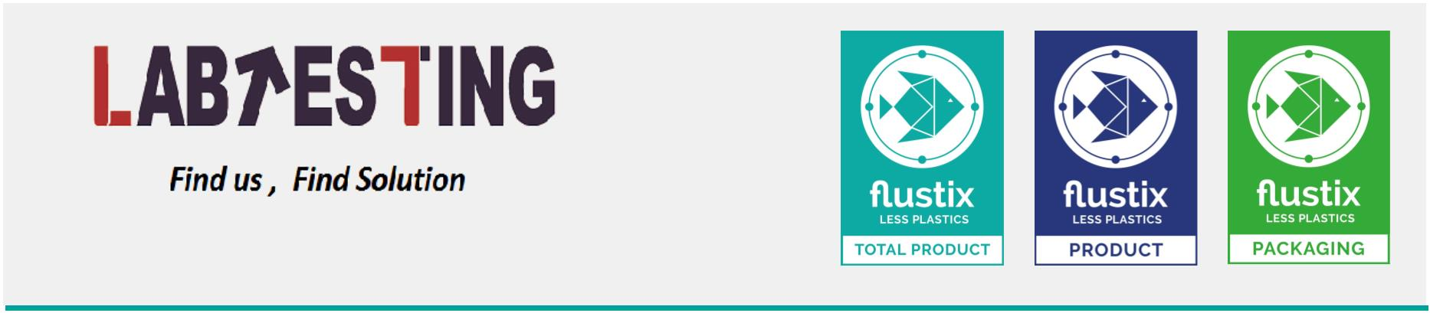

Application-No:
Application I flustix LESS PLASTICS
We apply for use of the following certiﬁcation marks:
Main Certiﬁcation
Type of Product:
Add-On / Amendment
Sublicence
Please complete a separate Questionnaire for each product type!
Product Name (Trade Name):
This Name will be published on Data Base & Certificate
EAN or GTIN or UPC:
If Add-On or Sublicense:
flustix Certification No.:
Manufacturer:
Street, Postal Code:
We apply for certiﬁcation of:
an end product
an intermediate
Which trustmark do you want to apply for?
Issuance of the trustmarks possible in 27 oﬃcial languages
LESS PLASTICS
LESS PLASTICS
LESS PLASTICS
TOTAL PRODUCT
PRODUCT
PACKAGING
Total Product
Product
Packaging
This seal looks at the product
and the packaging.
Both components are tested
independently of each
other and must meet the
requirements in their respective
segments in order
to be successfully licensed.
to be successfully licensed.
This flustix certification is
A great deal of plastic can
usually be saved in the packaging
of consumer goods:
Packaging that is at least 95%
plastic-free can be labeled with the
green seal after successful
licensing.
available for plastic-sustainable
products (without packaging).
Depending on the specific
product category, products that
can be free of plastic to specific
a limit value of at least 97% and
up to 99,79% may bear the
blue flustix seal.
Page: 2 / 4 As of: 21/05/2025
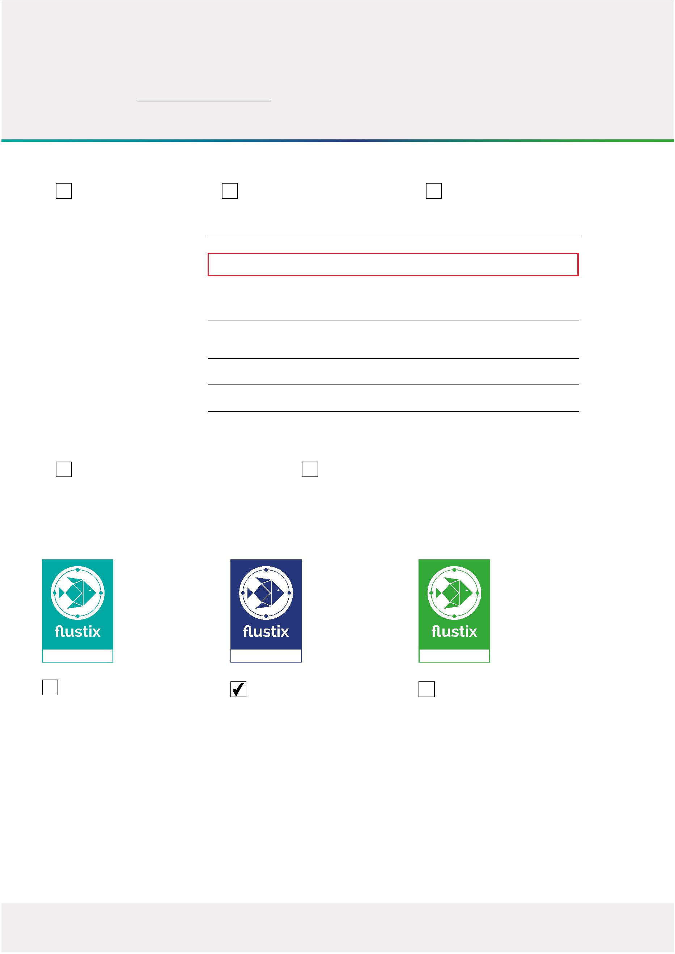

Application-No:
Application I flustix LESS PLASTICS
Classification of the Product / Packaging / Intermediate (xx% Polymer limit within mass weight percentage)
Paper Products / Take Away (<0.75% / <1.25% / <2% limit)
Recycled Fiber Paper Products (<3% limit)
Packaging (<2% / <3,5% / <5% limit) for:
Soil Additives / Fertilizer (<0.2% limit)
Textiles (<0.2% limit)
Other, e.g., Organic Residues (<0.2% limit):
Further information
Coated / lining
Coloured
Multi-layer structure
Water based dispersion
Includes
Masterbatch
Glue
Recycled Fibre Materials
Virgin Fibre Materials
If applicable:Please fill in these columns for paper products & packaging
Mandatory:
Size(s)
Single or Double Wall thickness Grammage
Wall (See info below) in µm
Coating / lining
thickness (in µm)
in gsm
Note: Please complete a separate Questionnaire for each product type (e.g., Single Wall and Double Wall cups).
I confirm that the sizes listed above are identical in composition apart from different size.
Yes
No
Page: 3 / 4 As of: 21/05/2025
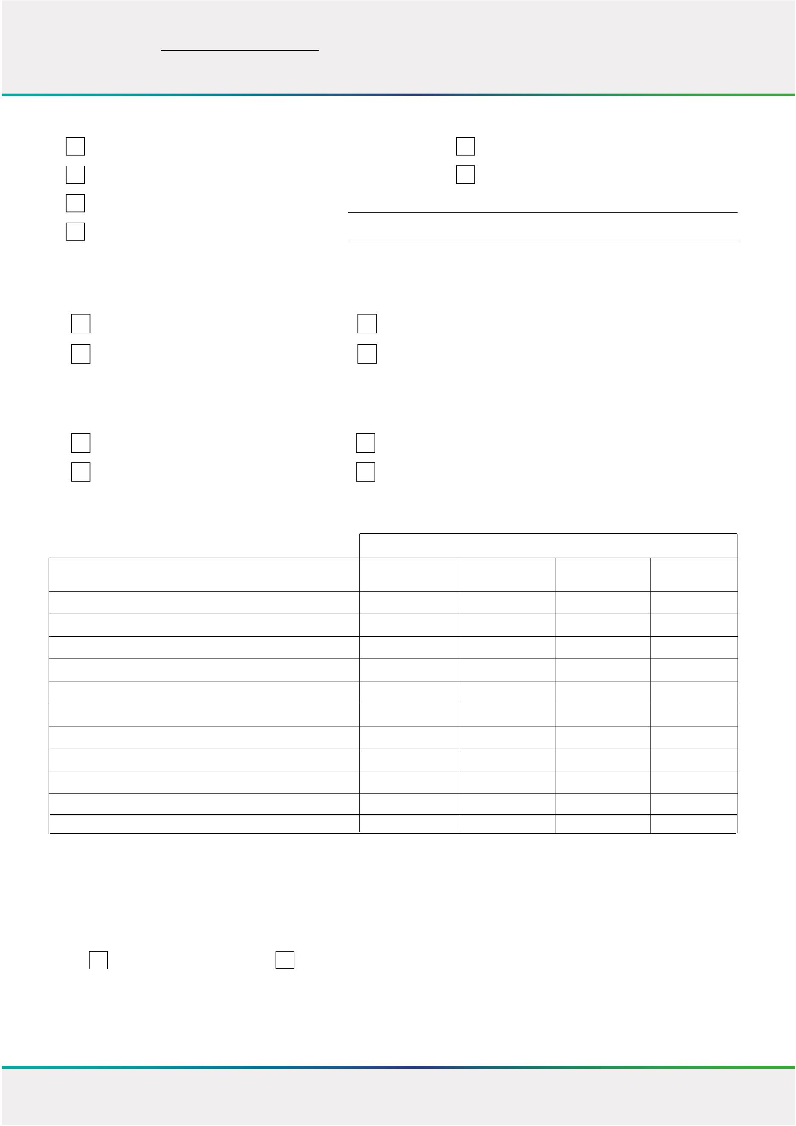

Application-No:
Application I flustix LESS PLASTICS
Material composition of the product
Materials
Percentage by mass in
% (dry weigt)
component
optional: manufacturer
(can speed up the process)
Applied max. thickness
(in µm)
If applicable: Additives (e.g.: inks, glue, coating, lining ...)
Percentage by mass in
% (dry weigt)
component
optional: manufacturer
(can speed up the process)
Applied max. thickness
(in µm)
Annex documents
Yes
No
Legal Disclaimer | Legal Notice Regarding the Application Form and Process
We hereby confirm the accuracy of all details furnished in the questionnaire and accompanying documents, ensuring their complete
alignment with the submitted samples and the products undergoing testing and certification. Additionally, we affirm that the
products submitted for certification are representative and identical to those that will be marketed post-certification. This application
form (Step 1) serves solely for the purpose of creating an individual offer, tailored to your request. A binding order will only be
established when you accept and sign the individual offer created in Step 2, based on details of this application. Only with your
signature accepting the official offer (Step 2) does the application become effective and the process of commissioning completed
as well as the selected certification initiated according to the offer.
Signature of applicant
Place, Date
Page: 4 / 4 As of: 21/05/2025
